What is independent advocacy?
Independent advocacy helps you to make your voice stronger and to
have as much control as possible over your life.

speak up for you
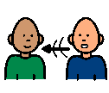
It is called independent because advocates and advocacy workers are
separate from services. They do not work for hospitals, social work or
other services.

There are different types of advocacy:
■ professional advocacy: an independent advocate works with you
to help you sort out your problem. The advocate might be paid or
be a volunteer.

make your voice stronger
■ citizen advocacy: an ordinary member of the public gets to know
you well over a long period of time. They stand alongside you and
help you to get what you need.

■ self-advocacy: people come together in groups to speak up about
things that are important to them. Self-advocacy groups try to
change the way people feel about themselves and change other
people’s attitudes. They also try to change services and policies.
This is also called collective advocacy.

collective advocacy
- peer advocacy: is when someone else with a learning disability helps someone with learning disabilities speak up for themselves.

peer advocacy
Why might I need independent advocacy?
Some people need support to speak up, to understand what is being
said and to make decisions. Many people find that when they feel ill or are
upset they are not as good at saying what they want and they need
support to speak up.

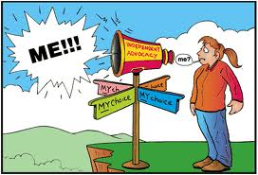

If you would like to speak to someone about advocacy or find out more about what we do, then please phone our office on:-
01382 205515
Or email us on:-
office@diasdundee.org
We look forward to hearing from you.

Picture Communication Symbols used with permission from Mayer-Johnson

